**Welcome to Loan Simulator Readme**

Once you pull the project from github. Open the project folder on eclipse. Right click on src/Main.java and run it.

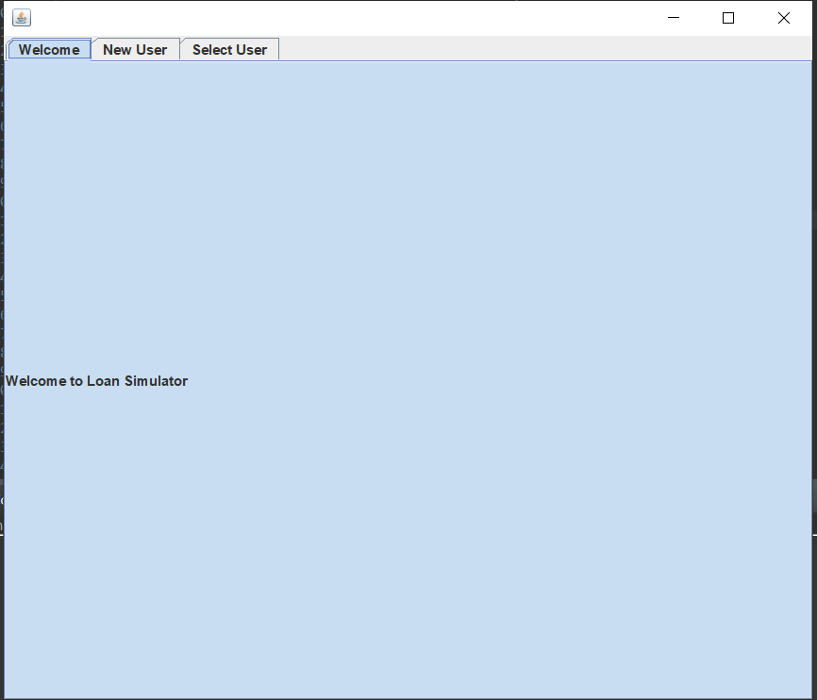

This is the welcome screen. Click on “new user” tab if you want to create new customer. Click on “select user” tab if you want to select existing user. ( Note that the program will save a file named “Customer” onto your desktop. You can delete this file after using our app.)

**New User**

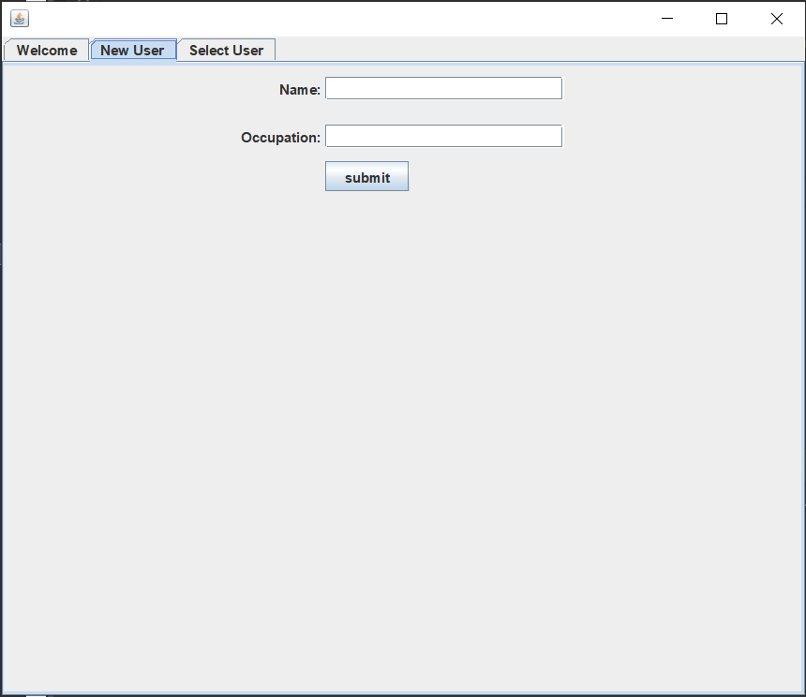

You can create a user by providing a name and occupation and click “submit”. Once created, the new user is available for selection in “select user” tab. Once you selected a user. “Loan application” tab and “Select Loan” tab will show up.

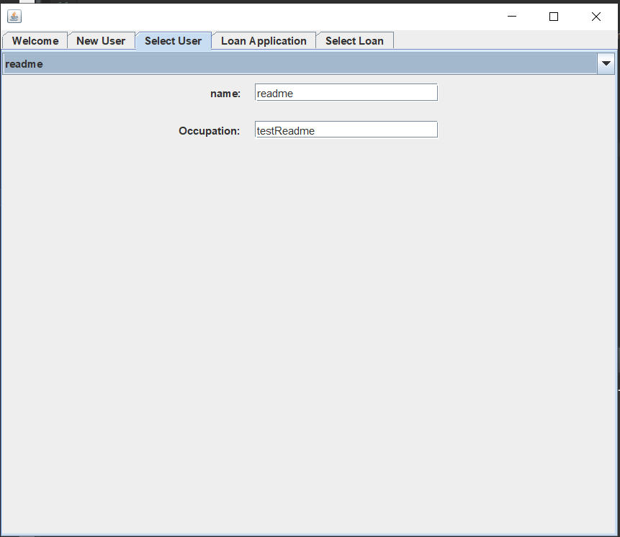

**Loan Application**

Fill up the form as shown in this screen. For now, all information are required. Then click “Apply” when finished.

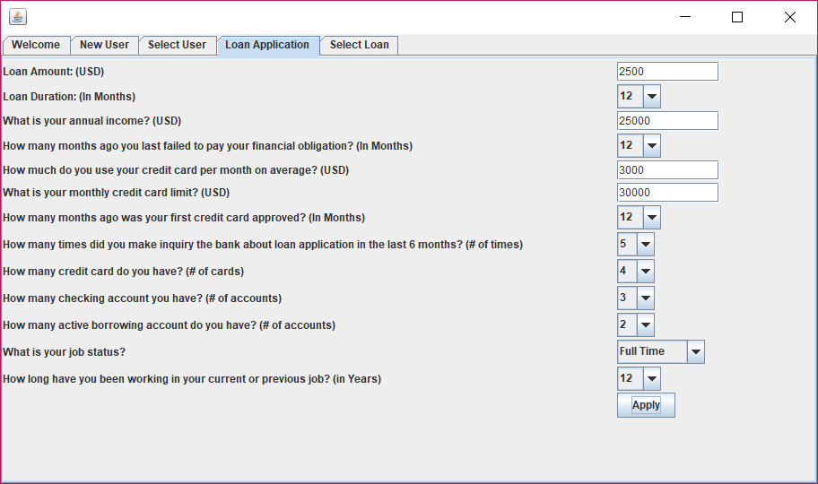

**Loan Amount:** How much you would like to borrow from the bank

**Loan Duration:** For how long do you want to borrow a loan from the bank

**Annual Income:** Your annual income

**How many months ago since you last failed to pay your financial obligation?:**

It can be approximate as it depends on your memory. If you have always paid all your obligations on due, please choose “0”

**How much do you use your credit card per month on average?:**

It asks your monthly average credit card amount usage

**What is your credit card limit?:** This is your monthly credit card limit

**How many months ago was your first credit card approved?:**

This asks when your first account was open

**How many times did you make inquiry the bank about loan application in the last 6 months? (# of times):**

This asks how many times you went to the bank to ask for the loan in the last 6 months

**How many credit card accounts, check card accounts, existing loan accounts?:** As the question suggests

**What is your job status?**: It asks whether you work for FT, PT or Unemployed

**How long have you been working in your current or previous job?**: It asks for the length of your employment. If it less than 1 year, please pick “1”.

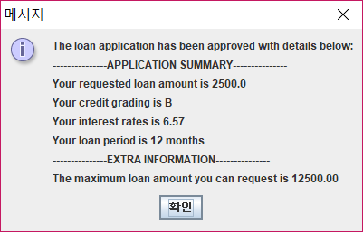

Once you input all the required information, then the summary window will pop up.

**Select Loan**

You can select the approved loan here. The details of the loan will be displayed.

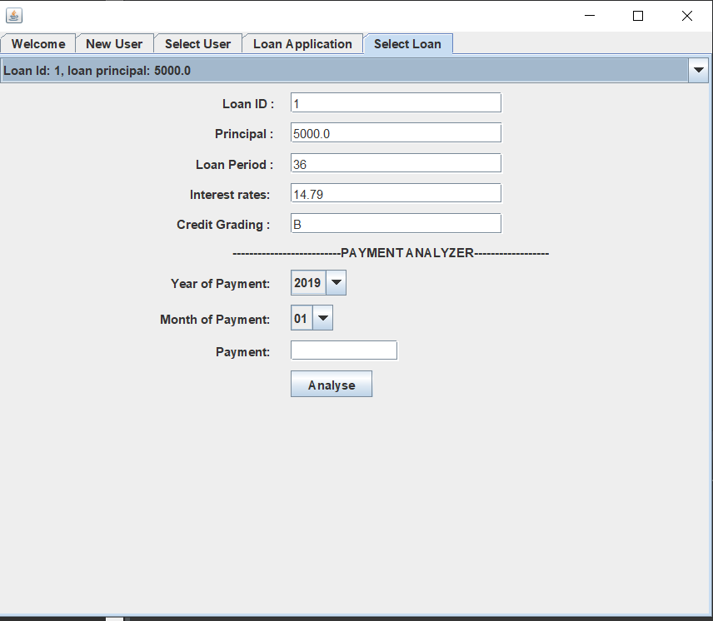

**Payment Analyzer**

Select the year of payment and month of payment and the amount of payment you want to make as below. Then click “Analyse”

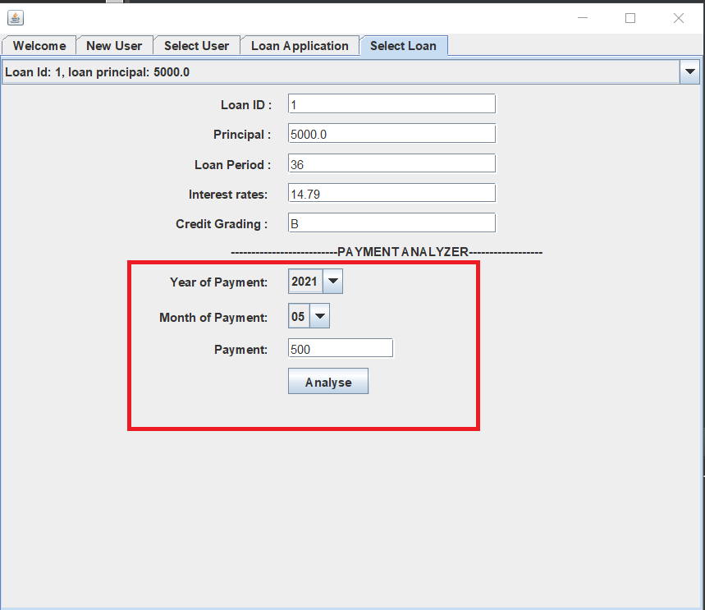

Then, it will calculate the amount due and display it.

